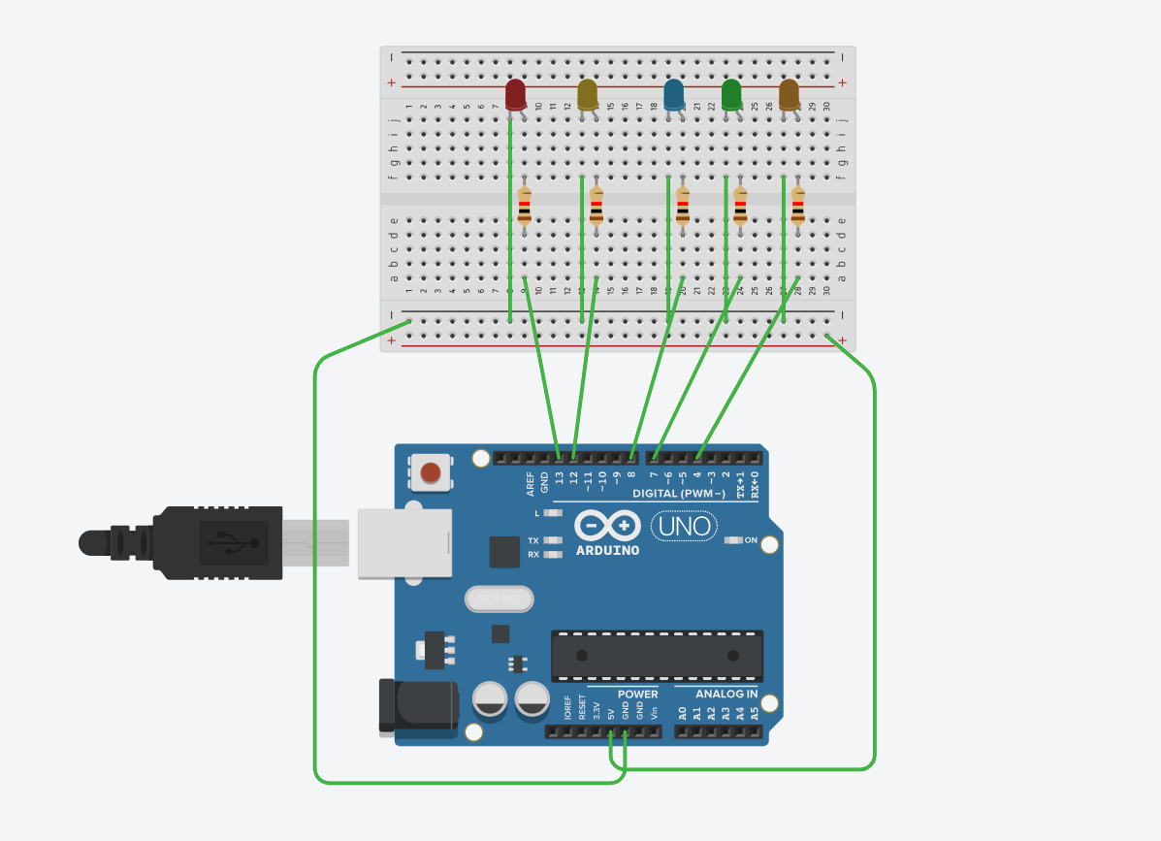

Code:- int l1 = 13;
int l2 = 12;
int l3 = 8;
int l4 = 7;
int l5 = 4;
void setup()
{
pinMode(l1, OUTPUT);
pinMode(l2, OUTPUT);
pinMode(l3, OUTPUT);
pinMode(l4, OUTPUT);
pinMode(l5, OUTPUT);
}

void loop()
{
digitalWrite(l1, HIGH);
delay(200); // Wait for 1000 millisecond(s)
digitalWrite(l1, LOW);
delay(100); // Wait for 1000 millisecond(s)

digitalWrite(l2, HIGH);
delay(100); // Wait for 1000 millisecond(s)
digitalWrite(l2, LOW);
delay(100); // Wait for 1000 millisecond(s)

digitalWrite(l3, HIGH);
delay(100); // Wait for 1000 millisecond(s)
digitalWrite(l3, LOW);
delay(100); // Wait for 1000 millisecond(s)

digitalWrite(l4, HIGH);
delay(100); // Wait for 1000 millisecond(s)
digitalWrite(l4, LOW);
delay(100); // Wait for 1000 millisecond(s)

digitalWrite(l5, HIGH);
delay(100); // Wait for 1000 millisecond(s)
digitalWrite(l5, LOW);
delay(100); // Wait for 1000 millisecond(s)
}

